Location: Vancouver School of Arts and Academics, 3101 Main Street, Vancouver WA (parking on east side of school)
Site Host: Lower Columbia River Music Educator Association, Ann Medellin, ann.medellin@vansd.org
Bring: Your instrument, snacks and water, lunch or money

10:00 – Noon
Open Reading Session with backing tracks and a mini global techniques lab
We’ll use this session to explore a number of styles, the right- and left-hand techniques necessary to capture each style, as well as non-classical rhythmic beds. We’ll also touch on how classes can create their own backing tracks and why they serve as such important gateways into global roots music. We’ll start with Irish, Bollywood, and blues… then, whatever else we can fit in! Pathways into improvisation in these styles will be included.

LUNCH

1:00 - 3 PM
How to Use the Looper to Stimulate Creativity, Composition and Rhythmic Precision
Julie will demonstrate the use of the looper and then we’ll form small looping circles. You will learn how to generate and teach bass lines, rhythm (chop technique as well as other techniques), riff-based melodic ideas (harder than one would think) and harmony. Looping circles have the potential to stimulate composition, improvisation, deep listening and ensemble skills without having to mention this to your students. They will just focus on how cool the looper is. And you don’t need a looper or an electric instrument to inspire your students to learn these skills. Julie will supply links to some Youtube videos!

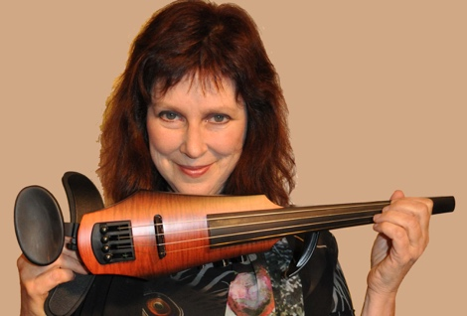
Julie Lyonn Lieberman (www.JulieLyonn.com) is an eclectic styles violinist and vocalist who specializes in improvisation and American vernacular as well as world styles. Ms. Lieberman has helped build what she calls "stylistically inclusive 21st century music education" over the last thirty-plus years through her work as an educator, author, radio producer, composer, recording artist, journalist, and performer. She authored the “Creative Musicianship” section of the American String Teachers National Curriculum book (published by Alfred) and is the Artistic Director for the summer program, Strings Without Boundaries.
Julie Lyonn Lieberman is the author of eight music books, two National Public radio series, six DVDs, and over fifty magazine articles. She designed a 2010 national eco-program, has co-authored several books and overseen the creative design and edits for three books. Julie is currently working on a creative memoire. Book titles include The Creative Band and Orchestra, The Contemporary Violinist, 12 Rock Strings Lesson Plans, Improvising Violin, Rockin' Out With Blues Fiddle, You Are Your Instrument, Planet Musician and Alternative Strings: The New Curriculum. DVD titles include Violin and Viola Ergonomics: Determine the Optimum Playing Position and Support For Your Body Type, Rhythmizing the Bow, Techniques for the Contemporary String Player, The Violin in Motion, and Vocal Aerobics. In 2007, she wrote and produced the DVD Alternative String Styles in the Classroom for American String Teachers Association and NAMM.

Fees for Washington American String Teachers $60
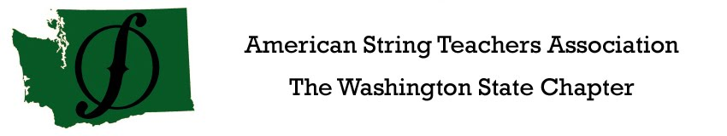
Non-Members $80
LCRMEA Members- $0

LCRMEA
Lower Columbia River
Music Educators Association

